GLOBAL SUPPLY CHAIN ANALYSIS

DASHBOARD

# A PROJECT REPORT

### Submitted by

**NITHISH N (22ALR060)**

### PRADAKSHINA S.B (22ALR064)

### YOGANANTH J (22ALL123)

***For***

# 22ADF01 DATA ANALYSIS

**DEPARTMENT OF ARTIFICIAL INTELLIGENCE**



# KONGU ENGINEERING COLLEGE

**(Autonomous)**

# PERUNDURAI ERODE – 638 060

**NOVEMBER 2024**

# DEPARTMENT OF ARTIFICIAL INTELLIGENCE

# KONGU ENGINEERING COLLEGE

### (Autonomous)

### PERUNDURAI , ERODE – 638 060

**NOVEMBER 2024**

**DEPARTMENT OF ARTIFICIAL INTELLIGENCE**

### 22ADF01 – DATA ANALYSIS

Signature of course in-charge Signature of the HOD

Submitted for the continuous Assessment viva voice examination held on

**EXAMINER I EXAMINER II**

# ABSTRACT

In the face of growing global market demands, optimizing supply chain performance is crucial for maintaining competitiveness and resilience. This analysis leverages the DataCo Global Supply Chain dataset to evaluate key factors such as supplier reliability, order lead times, logistics performance, and regional distribution, utilizing Power BI for advanced visualization and predictive analytics. Through data pre-processing in Power Query Editor and the creation of calculated measures and custom columns, the study identifies bottlenecks, forecasts demand, and highlights opportunities for cost reduction, efficiency improvement, and risk mitigation. The interactive dashboard integrates advanced features such as drill-throughs, dynamic filtering, and real-time KPI tracking, providing actionable insights into supplier performance, delivery timelines, inventory levels, and cost effectiveness. Predictive models incorporated into the analysis offer forecasts for demand patterns and potential disruptions, while scenario analysis evaluates the impact of various strategic decisions. By aligning analytics with business goals, this approach empowers stakeholders to make data-driven decisions that enhance customer satisfaction, optimize resources, ensure scalability, and build a more resilient and adaptive supply chain strategy.

**TABLE OF CONTENTS**

|  |  |  |
| --- | --- | --- |
| **CHAPTER**  **No.** | **TITLE** | **PAGE NO.** |
|  | **ABSTRACT** | **3** |
|  |  |  |
| **1.** | **INTRODUCTION** | **5** |
|  | 1.1 INTRODUCTION | **5** |
|  | 1.1.1 DATA COLLECTION | **6** |
|  | 1.2 PROBLEM STATEMENT | **7** |
|  | 1.3 BUSINESS OBJECTIVE | **7** |
| **2.** | **DATA PREPARATION AND MODELING** | **8** |
|  | 2.1 DATA CLEANING | **8** |
|  | 2.2 DATA TRANSFORMATION | **8** |
|  | 2.3 DATA MODELLING | **13** |
|  | 2.4 DAX FUNCTIONS | **16** |
| **3.** | **DATA ANALYSIS AND INTERPRETATION** | **21** |
|  | 3.1 DATA ANALYSIS | **21** |
|  | 3.2 PUBLISHING DASBOARDS | **29** |
|  | 3.3 INFERENCE | **32** |
| **4.** | **CONCLUSION** | **34** |
|  | 4.1 RECOMMENDATIONS | **34** |
| **5.** | **REFERENCES** | **35** |

## CHAPTER 1

**INTRODUCTION**

## INTRODUCTION

* + - The dataset that is given for analysis and visualize it using dashboard were “DATACO”. The dataset is collected from Kaggle and it contains mostly all the attributes essential for creating visuals and dash boards. The dataset is available in comma separated values (csv) format.
    - We can directly download data’s from Kaggle and import them into power bi file. A unified, scalable platform for self-service and business intelligence in enterprises is called Power BI.
    - Connect to any data, visualize it, and easily integrate the visualisations into the daily-use apps you use. Then the collected datas are subjected for pre-processing. In data preprocessing it involves filtering, cleansing, de-duplicating, validating and finally authenticating data.
    - Formatting the data into tables or joined tables to match target schema. Performing calculations, translations, summarizations, changing rows and columns data type, change null values, apply DAX measures, etc.
    - Power BI offers desktop-based Power BI Desktop and cloud-based BI (business intelligence) services, together referred to as "Power BI Services".
    - It delivers interactive dashboards, data discovery, and data preparation tools for data warehouses. On its Azure cloud platform, Microsoft introduced a new service called Power BI Embedded in March 2016. The product's ability to load customized visuals is one of its key differentiators.

## DATA COLLECTION

The process of gathering, measuring, and analyzing precise insights for research using accepted, established methods is known as data collection. A researcher can assess their hypothesis using the data that they have gathered. No of the subject of study, gathering data is typically the first and most crucial phase in the research process. Depending on the type of data needed, different disciplines of research require different approaches to data gathering.

### DATASET

The dataset is collected from Kaggle. The dataset contains 3 tables namely

* Dataco.csv
* DescriptionDataCoSupplyChain.csv
* tokenized_access_logs.csv

The **DataCo Smart Supply Chain Dataset** on Kaggle is designed for big data analysis of supply chain operations. It includes comprehensive details on transactions across different stages, such as product information, order status, shipping details, and customer demographics. Key columns include variables related to product categories, sales performance, shipment dates, delivery times, profit margins, and market segments. This dataset is ideal for analyzing factors impacting supply chain efficiency, customer satisfaction, and profitability, and is particularly suited for machine learning, forecasting, and visualization projects to optimize supply chain processes.

* + - <https://www.kaggle.com/datasets/shashwatwork/dataco-smart-supply-chain-for-big-data-analysis?select=DataCoSupplyChainDataset.csv>
    - <https://www.kaggle.com/datasets/shashwatwork/dataco-smart-supply-chain-for-big-data-analysis?select=DescriptionDataCoSupplyChain.csv>
    - <https://www.kaggle.com/datasets/shashwatwork/dataco-smart-supply-chain-for-big-data-analysis?select=tokenized_access_logs.csv>

## PROBLEM STATEMENT

The **DataCo Smart Supply Chain Analysis** seeks to optimize complex supply chain operations to enhance efficiency, reduce costs, and boost customer satisfaction. Using the comprehensive DataCo dataset, this analysis examines key factors like order processing times, shipment efficiency, inventory management, and customer purchasing patterns. The goal is to identify bottlenecks, improve supplier reliability, and optimize stock levels to meet demand without overstocking. By leveraging data insights in Power BI, this analysis aims to provide actionable strategies for demand forecasting, cost reduction, and performance improvement across the supply chain, ultimately supporting a smarter, more resilient supply chain framework.

## BUSINESS OBJECTIVE

1. Improve operational efficiency by identifying and reducing bottlenecks in order processing and shipment.
2. Optimize inventory management to balance stock levels with demand, reducing holding costs while ensuring product availability.
3. Enhance customer satisfaction through timely order fulfillment and reliable service.
4. Strengthen supplier performance by evaluating reliability and minimizing supply chain disruptions.
5. Forecast demand trends to adjust resources proactively and support data-driven decision-making.
6. Increase overall profitability by reducing costs across supply chain operations and improving cost-effectiveness.

**ABOUT POWER BI:**

1. Power BI is a business analytics tool from Microsoft that helps users create interactive visualizations and share insights across an organization.
2. It allows business users to track key metrics and goals in one place, making it easy to collaborate and stay on top of performance.
3. With busy schedules, people often lack time for entertainment or detailed cricket analysis, so summarizing events in a simple and attractive way is necessary.
4. Power BI helps create dynamic and interactive dashboards to visualize cricket match data in an easy-to-understand way.
5. Power BI simplifies decision-making by offering a range of interactive visualizations and business intelligence features.

## CHAPTER 2

**DATA PREPARATION AND MODELING**

## DATA CLEANING

Data cleaning is the process of removing errors from the data by filling in missing values, smearing noisy data, analyzing and removing outliers, and smoothing noisy data. Data at various degrees of detail may occasionally diverge from what is needed Missing Values – Appropriate values are substituted for missing values. The strategies listed below

* + - When a tuple contains many attributes with empty values, it is
    - Disregarded.
    - For the missing value, the values are manually filled in.
    - The values may be filled with the same global constant.
    - The attribute mean can replace the values that are absent.
    - The most likely value can be used to fill in the blanks.

## DATA TRANSFORMATION

1. The process of changing data from one format or structure to another is known as data transformation. It is a crucial component of the majority of data management and integration jobs, including
2. Application **integration**, Data **wrangling**, Data **warehousing**, and Data **integration**. Depending on the required modifications to the data between the source (initial data) and the destination (final data), data transformation can be straightforward or difficult. The process of data transformation often involves both manual and automated procedures.
3. Depending on the format, structure, complexity, and amount of the data being changed, a broad range of tools and technologies may be employed. For decades, corporations have benefited greatly from using conventional data transformation techniques.
4. Since the development of the various tools and technologies (data profiling, data visualization, data purification, data integration, etc.), most (if not all) businesses now transform massive volumes of data that feed internal and external applications, data warehouses, and other data repositories.
5. So, Data Transformation is a required process inorder to preprocess the loaded data set as per our requirement and apply those changes for future use. It is while Data Analysis and creating DAX functions of those relations respectively.

## PROCEDURE

### STEP 1

1. Go to HOME tab in ribbon.
2. Click on GET DATA and select data from the system or from any platform where it resides.
3. Here select 6 different tables of CSV format from system and load it to POWER BI.

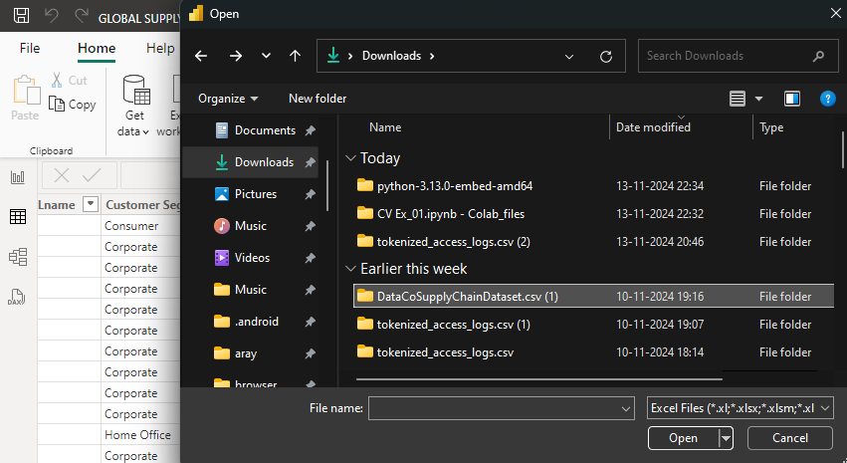

Figure 2.2.1 Select Dataset

### STEP 2

* 1. From the ribbon of HOME tan select TRANSFORM DATA inorder to clean and transform data.

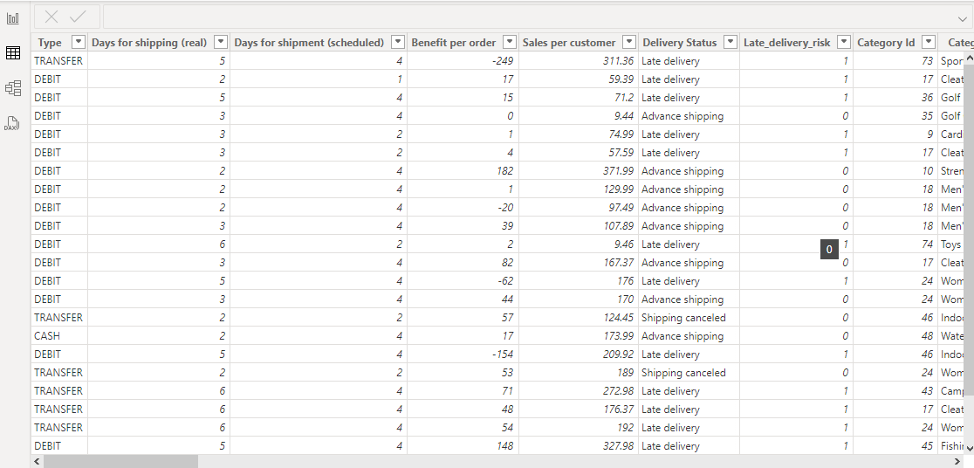

Figure 2.2.2Transform Data

### STEP 3

1. After choosing transforming data all the loaded tables and opened in POWER QUERY EDITOR, so that we can make any changes as per our wish.
2. Then open the SUMMARY table and replace the values which are blank.
3. Then try to add NULL values to the rows in which the matches are cancelled due to some reasons

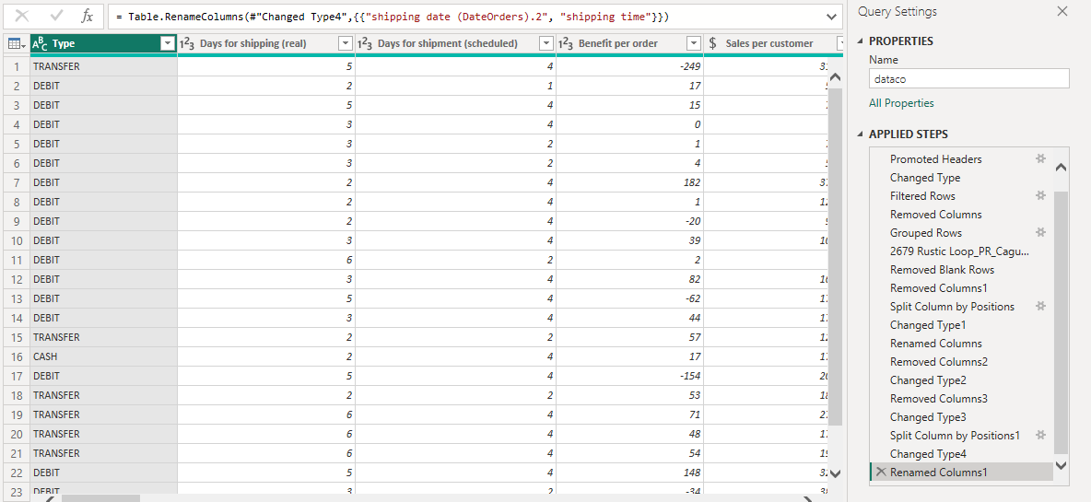

Figure 2.2.3 Power Query Editor

### STEP 4

1. Then on same SUMMARY table apply REPLACE VALUES.
2. In this select any column that need new values to be replaced for further processing

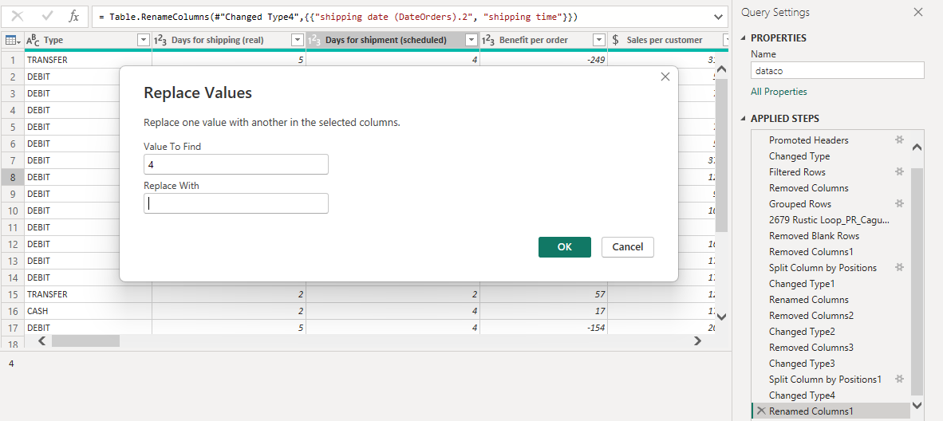

Figure 2.2.4 Replace Value

### STEP 5

1. Now select table to clean it.
2. Here applies change datatype so click the column that needed to change the datatype.
3. Select “Benefit_order” column then change its datatype to whole number.

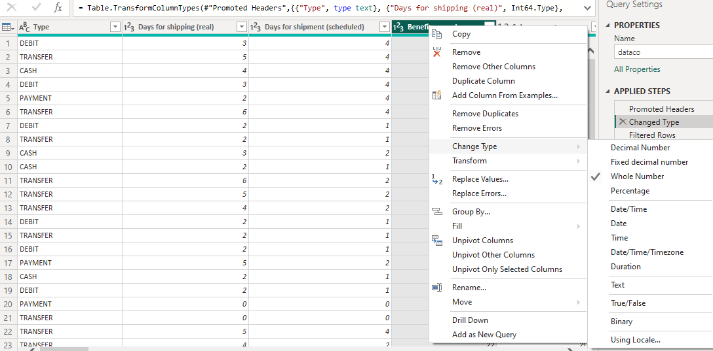

Figure 2.2.5 Change Column Type

### STEP 6

1. Now select table inorder to apply SPLIT COLUMN.
2. It is needed to split a particular column so that data can be accessed easily.
3. Select column to be splited, RIGHT CLICK the column.
4. Drop down the list displays and select SPLIT COLUMN.
5. Then select split column by DELIMITER.
6. Similarly, we can also split column by using delimiters such as comma, colon, semi solon, hyphen, etc...
7. Now split the column “order_date” from table into another columns by using delimiter “position”.
8. Then rename the newly created columns as “TIME”

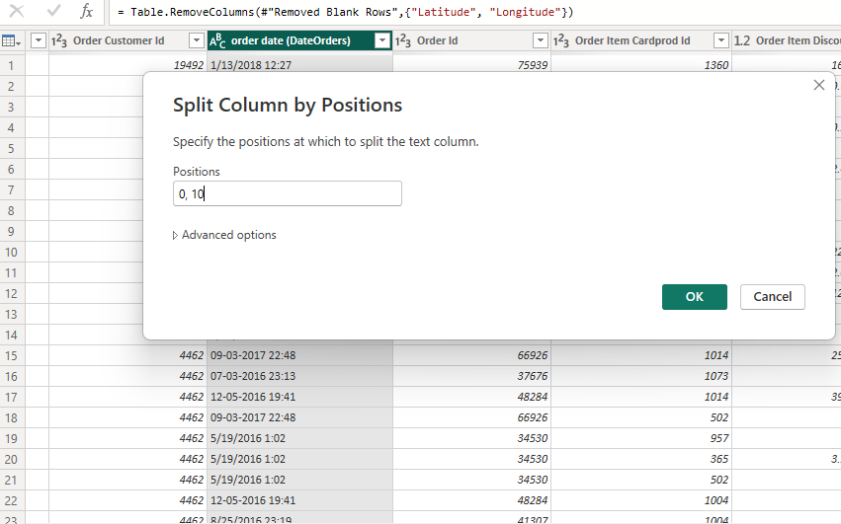

Figure 2.2.6 Split Column Selection

**STEP 7**

* 1. Select table and replace values.
  2. Replace 0 to NULL values.

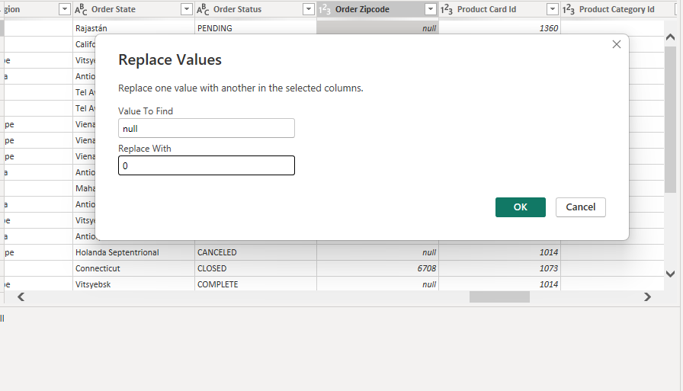

Figure 2.2.7 Details – Replace Value

**STEP 8**

1. Select table to make changes.
2. Select column commentary, right click to remove ERRORS.
3. Then in same table select ROW named blank and REMOVE it.



Figure 2.2.8 Replace NA values

### DATA MODELLING

Data modelling is one of the aspects used in BI tools to establish relationships between various data sources. When using several data sources, you can construct engaging data visualizations by defining the relationships between them.

It can create unique calculations on the already-existing tables using the modelling capability, and these columns can then be easily displayed in Power BI visualizations. This enables companies to create new measures and perform unique calculations for them.

Data Modeling is used to create relationship among the different tables inorder to access the data of different tables to visualize them. There are four types of relations that we can create as,

* + - One to One relationship
    - One to Many relationship
    - Many to One relationship
    - Many to Many relationship

### PROCEDURE

### STEP 1

**1**. Here start merging of columns to create relationship.

**2**.Select “Dataco” and “tokenized” tables then merge them by using common attribute as “ID” of both tables which act as primary key

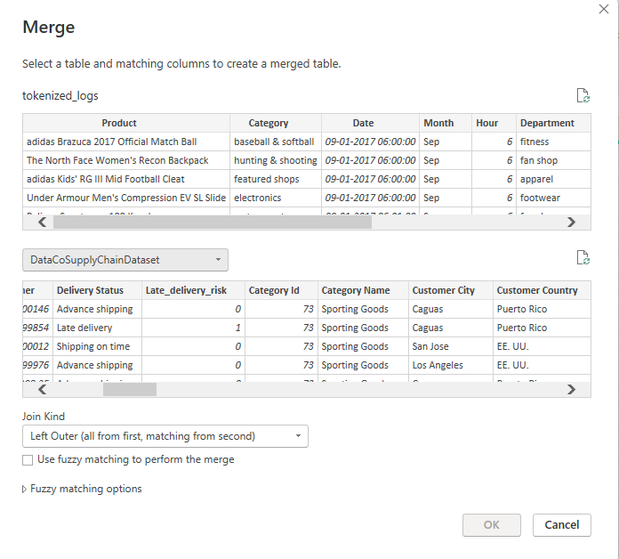

Figure 2.3.1 Merge Tables

### STEP 2

1. Similarly merge “description” and “tokenized_logs” tables.
2. Here “id” act as a common element and primary key.

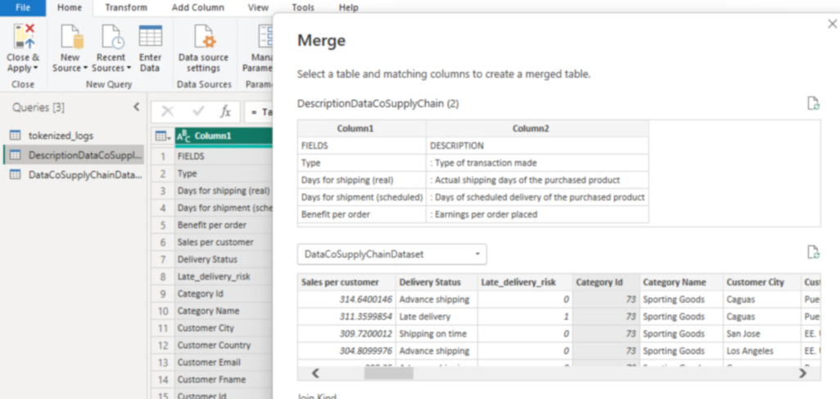

Figure 2.3.2 Merge Tables

### STEP 3

1. Select the tables “dataco” and “description” to merge them.
2. Merge them by choosing customer and season attributes from both tables.

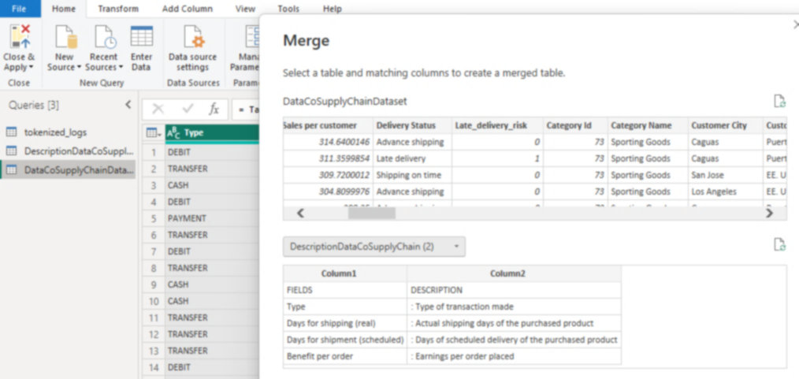

Figure 2.3.3 Merge tables

### STEP 4

* 1. After applying changes and merging tables select “close” and “apply” from ribbon of Power query Edito.
  2. At Power bi desktop it displays table as visualised below Figure 2.3.4.

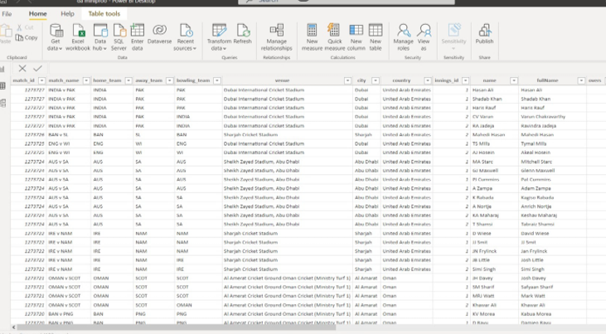

Figure 2.3.4 Power Bi desktop after transformation.

## DAX (Data Analysis Expressions)

DAX is a special function that contains collection of operators, formulae, functions, expressions to calculate, process and execute the values from existing table and return one or more values as the result of respective functions. So, it is used to create new information from the data that already exist in the table while creating model and analyzing it.

DAX measured of Power Bi are special functions or Programming Language that are used to create the following such as

* + - Calculated columns
    - New measures
    - Customized tables
    - Quick measures
    - Implement Time Intelligence

There exist many formulae for creating the new columns, measures. The time intelligence are special functions the are applicable only for the Time-based columns only.

So, from these formulae and expression we can find results like maximum, minimum, average, count, sum, filters, difference, total, variance, percentage, addition, subtraction, division, etc.….

### STEP 1

1. Creating Quick measure for table dataco.
2. Click Quick measure at ribbon and a menu pop up
3. Measure named “Total_Sales” by choosing “Region” and click on ok.

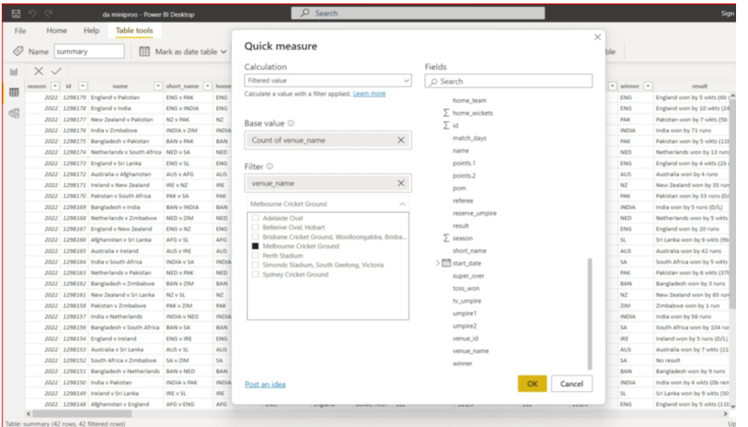

Figure 2.4.1 Quick measure

### STEP 2

1. Create calculated column dataco table
2. Select table,” Right click” it then selects “New column”.
3. Apply formulae for new table in the given box with new name click enter Formula for new column:

Total Sales per Region =

CALCULATE(

SUM('dataco’[Sales]),

ALLEXCEPT('dataco', 'dataco'[Order Region]))

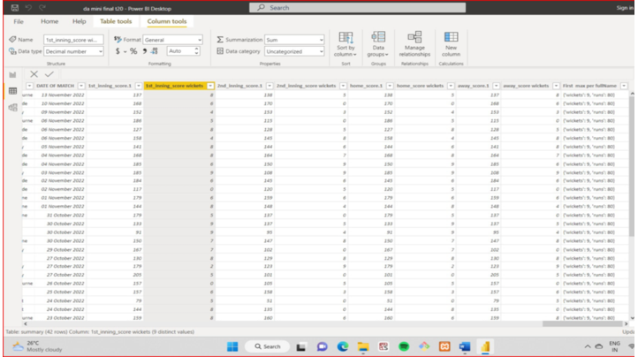

Figure 2.4.2 New column creation

### STEP 3

1. Create new measure for table “tokenized_access_log” table.
2. Create new measure called as “Total_category”
3. Now right click “tokenized” table and choose new measure to create it.
4. Apply the required formulae with new name and click enter. Formula for measure:

Total category =

CALCULATE(

    SUM('tokenized_access_logs'[Category])

)

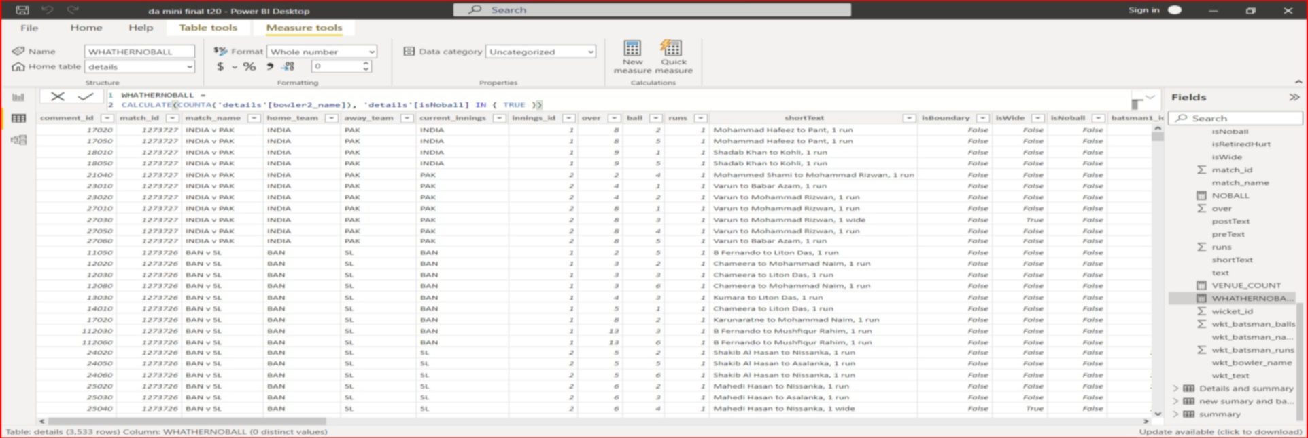

Figure 2.4.3 New Measure created

### STEP 4

1. Now create relationships for the various tables that we used.
2. From left ribbon select MODEL to create relationships.
3. All the tables of model will be displayed here.
4. For each table use Primary key or foreign key to create relationships either one to one, one to many, many to one, many to many respectively.

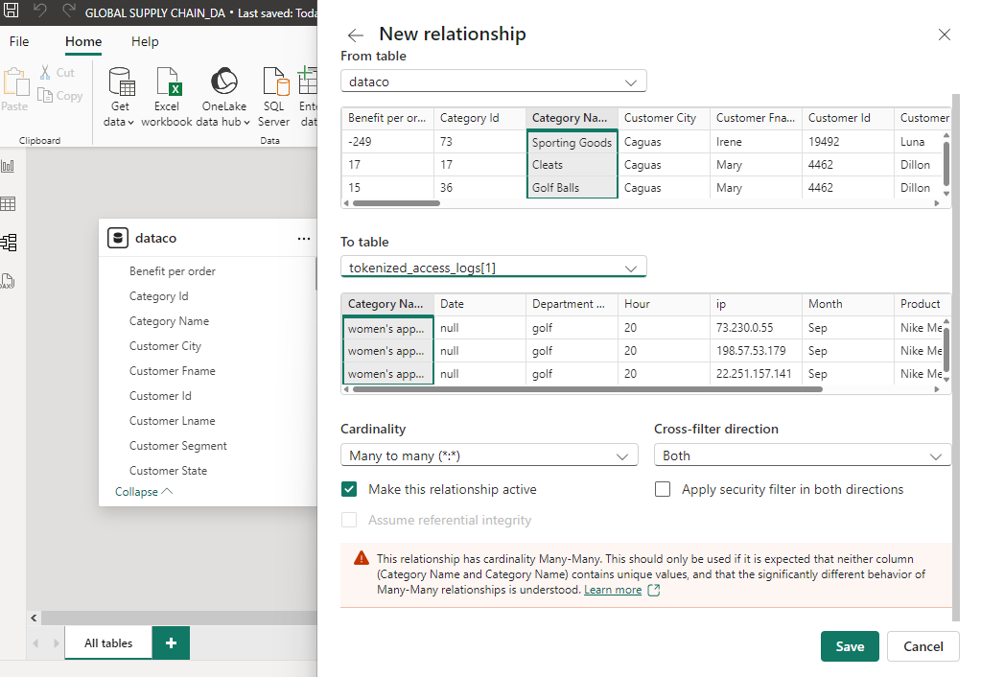

Figure 2.4.4 Relationship creation

### STEP 5

1. Select all the tables available in the model.
2. For each table select primary key and merge it with another table to create relationships.
3. For example “id” from “dataco” and similarly “id” from “tokenized_access_log” table which will create the one to one relationship.
4. Similarly create as many relations as required.
5. The finally view it at MODEL and also view it like below image.

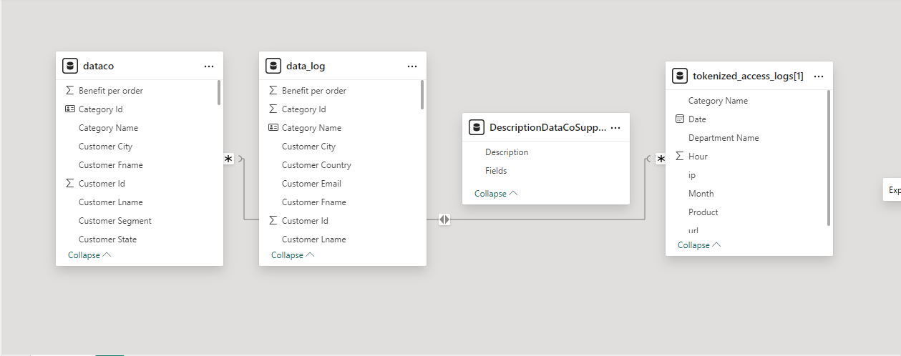

FIG 2.4.5 Relationship View

### STEP 6

1. Creating calculated column for table “tokenized”.
2. Select “tokenized_access_log” right click it and select new column and then apply the following formula.

Count =

CALCULATE (COUNTA ('tokenized_access_logs[1]'[Product]), 'dataco'[Product Price])

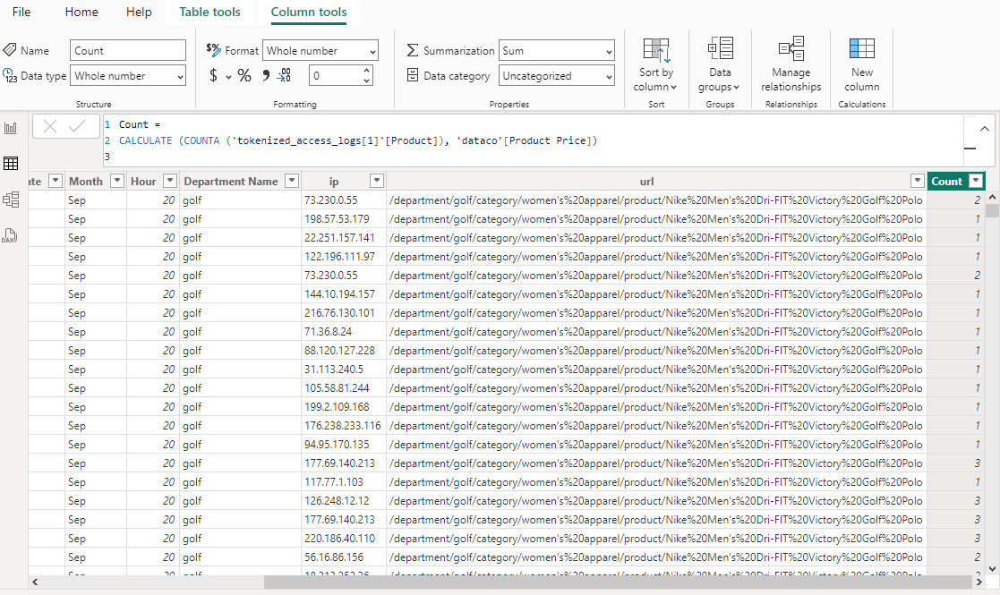

FIG 2.4.6 Creating Calculated column

### STEP 7

1. Calculating maximum of order by using the following formula.

MAX = MAX ('DescriptionDataCoSupplyChain (2)'[Fields])

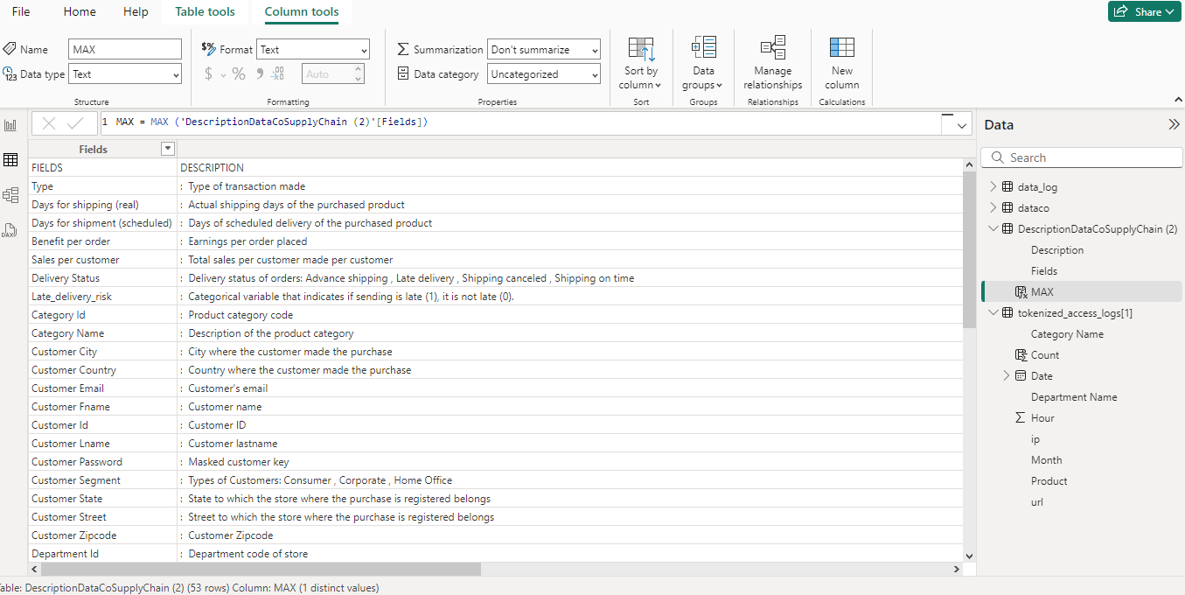

FIG 2.4.7 Calculating maximum of order

# CHAPTER 3

### DATA ANALYSIS AND INTERPRETATION

### 3..1 DATA ANALYSIS

To turn raw data into insightful information, data analysis is the process of analyzing, manipulating, and monitoring. Making the necessary decisions for a business or company's growth is made easier with the use of data insights. Deep data analysis is crucial if need want to manage a firm that is data-driven. Then it is needed to find learning different Power BI data analysis approaches fascinating and useful.

Data analysis includes the following results

* + Used to create various charts from Power Bi visuals
  + Select datas from various tables, analyse it and convert it into visuals.
  + From the analysed result infer the result or final solution.

**CHARTS**

**1. Solve for Total Sales per Region to determine sales distribution.**

Select table dataco

Include calculated measure “Total Sales”

Then select **card chart** for visualization.



Figure 3.1.1 Number of regions

1. **Relate market share to the shipping category to assess market reach.**

Select table dataco.

Include the columns.

Then select **matrices** for visualization.

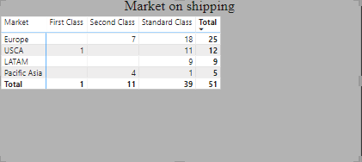

Figure 3.1.2 Market on shipping

**3. Sketch late delivery rates by product using stacked column charts to illustrate delivery performance**.

Select table.

Include calculated measure.

Then select **stacked column chart** for visualization.

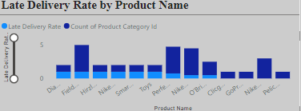

Figure 3.1.3 Late Delivery Rate by Product name

**4. Use a geographical map to categorize and illustrate how total sales are distributed across regions.**

Select table dataco.

Include calculated measure.

Then select **map** for visualization.

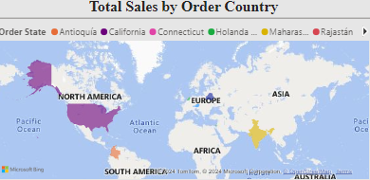

Figure 3.1.4 Total Sales by Order country

## 5. Complete a visualization of total sales by type to interpret sales patterns

Select table.

Include calculated measures.

Then stacked columnchart for visualization.

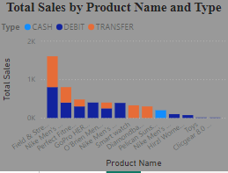

Figure 3.1.5 Total Sales by Type

1. **Articulate filters or slicers by Region, Product Category, and Order Status to allow for focused exploration of specific areas.**

Select table.

Include the columns.

Then **select slice** chart for visualization.

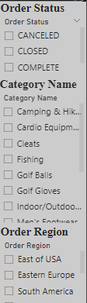

Figure 3.1.6 Areas of interest

**7.Identify and categorize the Top 5 Products by Sales in Each Region.**

Select table.

Include calculated measure

Then select **stacked column chart** for visualization.

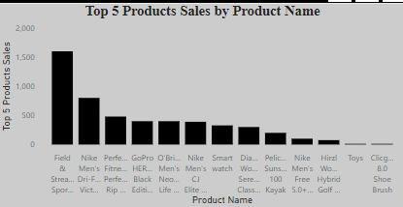

Figure 3.1.7 Percentage Change

**8. Calculate the total number of products to summarize inventory scale.**

Select table.

Include calculated measure.

Then chart **select card** for visualization.

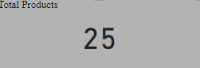

Figure 3.1.8 Total Products

**9.Distill Profit Margin by Product Category to analyze profitability.**

Select table.

Include measures.

Then select **donut chart** for visualization.

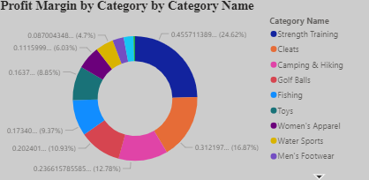

Figure 3.1.9 Profit

**10.Illustrate delivery status by category using a chart to contrast performance across categories.**

Select table.

Include calculated measure.

Then select **table chart** for visualization.

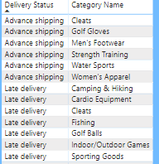

Figure 3.1.10 Delivery Status

**11.Categorize customer segments by total sales and profit to discover key customer profiles.**

Select table.

Include measures.

Then select donut chart for visualization.

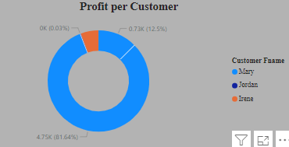

F Figure 3.1.11 Profit per customer

‘

**12.** **Relate the percentage of late deliveries by market using a chart to contrast punctuality.**

Select table.

Include columns.

Then select clustered column chart for visualization.

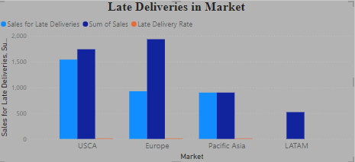

Figure 3.1.12 Late deliveries in Markets

**13.Devise a measure to calculate sales performance for each department.**

Select table.

Include columns.

Then select chart for visualization.

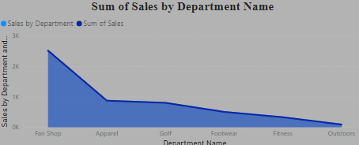

Figure 3.1.13 Sales by department

**14.Compute and articulate the benefit per order for each category to evaluate profitability.**

Select table.

Include measures.

Then select pie chart for visualization.

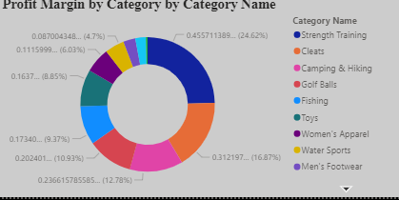

Figure 3.1.14 Benefit per order

**15.Distill total sales for each Order region to contrast regional performance.**

Select table.

Include measures.

Then select chart for visualization.

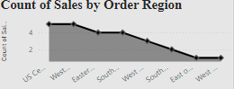

Figure 3.1.15 Order region

* 1. **PUBLISHING DASHBOARD**
     + Often referred to as a canvas, a Power BI dashboard is a single page that employs visuals to convey a story. A well-designed dashboard only includes the key components of the tale because it is only one page long. The dashboard's tiles—the visuals you see there—are placed there by report creators.
     + The report page where the visualisation was made is often the page you land on after picking a tile. A dashboard's visuals are derived from reports, and each report is built using a single dataset. A dashboard may really be thought of as a portal to the underlying reports and statistics.
     + Then it may get the report that was used to produce a visualisation by selecting Dashboards are an excellent method to keep an eye on your company, search for solutions, and quickly view all of your most crucial indicators.
     + A dashboard's visualisations might be drawn from a single underlying dataset or several, as well as a single underlying report or many.
     + Regardless of where the data is stored, a dashboard may mix on-premises and cloud data to provide a consolidated picture. A dashboard is interactive, and the tiles refresh as the underlying data changes. It is more than simply a lovely picture.

### Link for dashboard

<https://app.powerbi.com/groups/me/reports/0038abc1-7f47-4e85-b3bc-779e98372b2f/80f78287de4000db0e5b?experience=power-bi>

### Process of creating Dashboard

### STEP 1

1. Open Power Bi serviced in web browser.
2. From that interface click on get data at the left bottom.
3. Select import data from device or local disk.
4. Then import the created Power Bi.

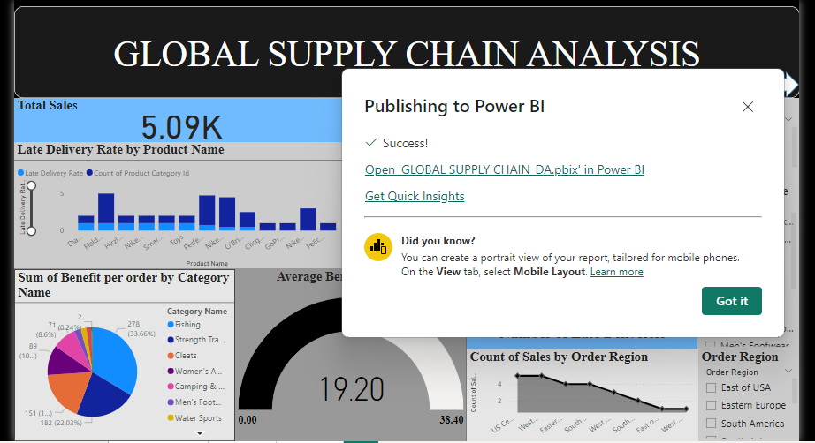

Figure 3.2.1 Importing dash board

**STEP 2**

1. Now select visuals from Power Bi file created and imported to dashboard.
2. Create new dashboard named “GLOBAL SUPPLY CHAIN DASHBOARD”.
3. Then pin them to the dashboard.

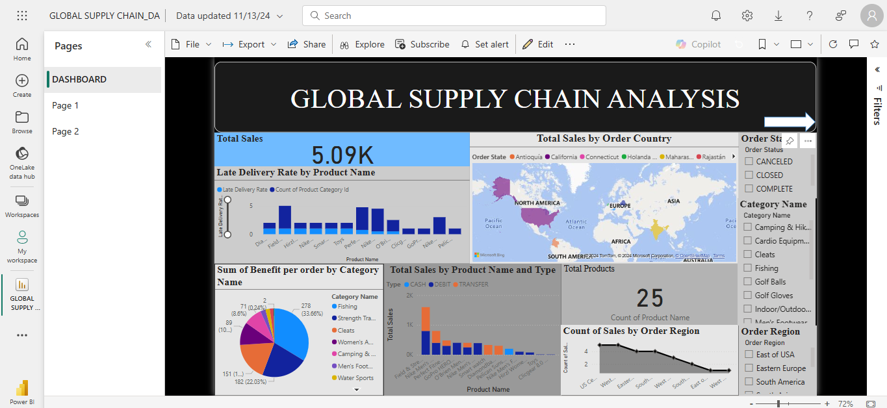

Figure 3.2.2 Creating new dashboard

### DASHBOARD VIEW OF GLOBAL SUPPLY CHAIN ANALYSIS

### PAGE 1:

Figure 3.2.3 Global Supply Chaint dashboard

**PAGE 2**

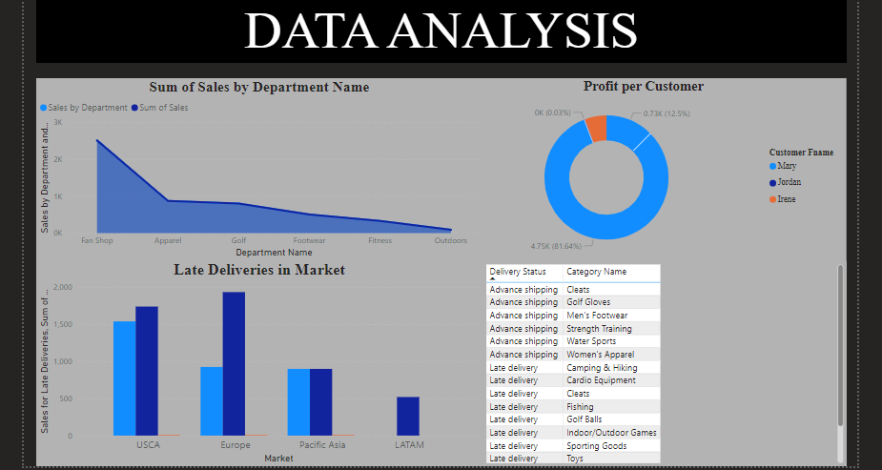

Figure 3.2.4 Global Supply Chaint dashboard

## INFERENCES

**1.Solve for Total Sales per Region to determine sales distribution.**

Total number of sales per region is 5.09 K.

**2.Relate market share to the shipping category to assess market reach.**

1. Europe 25
2. USCA 12
3. LATAM 9
4. Pacific Asia 5

**3. Sketch late delivery rates by product using stacked column charts to illustrate delivery performance.**

The product fitness has highest late delivery

**4.Use a geographical map to categorize and illustrate how total sales are distributed across regions.**

California has highest sales.

**5.Complete a visualization of total sales by type to interpret sales patterns.**

Pelican Sunstream only has the cash type.

**6.Articulate filters or slicers by Region, Product Category, and Order Status to allow for focused exploration of specific areas.**

Using filters or slicers helps stakeholders focus on specific regions, products, or order types, enabling customized insights and refined decision-making.

**7.Identify and categorize the Top 5 Products by Sales in Each Region.**

Smart watch,Perfect Fitness Perfect Rip Deck ,Toys,Nike Men's Free 5.0+ Running Shoe ,Hirzl Women's Hybrid Golf Glove

**8.Calculate the total number of products to summarize measure.**

A count indicates 25 products to summarize the measure.

**9.Distill total sales for each Order region to contrast regional performance.**

Categories with high benefits per order maximize revenue potential, highlighting profitable areas for marketing or sales efforts.

**10.Distill Profit Margin by Product Category to analyze profitability.**

Categories with high profit margin Strength Training is a key to revenue generation, suggesting areas to promote.

**11.Illustrate delivery status by category using a chart to contrast performance across categories.**

Categories with advanced shipping rates might benefit from improvements in logistics or supplier reliability to meet customer expectations.

**12.Categorize customer segments by total sales and profit to discover key customer profiles.**

Customer profiles can be identified, helping target high-value customer named Mary.

**13.Relate the percentage of late deliveries by market using a chart to contrast punctuality.**

High late delivery rates in certain markets suggest areas needing better supply chain coordination or enhanced service standards.

**14.Devise a measure to calculate sales performance for each department.**

Department name Fan shop with strong sales performance contribute significantly to overall revenue, guiding resource allocation or departmental focus.

**15.Compute and articulate the benefit per order for each category to evaluate profitability.**

Regions with high total sales reflect active markets with strong demand, while lower sales may

require different sales tactics or marketing approaches

# CHAPTER 4

**CONCLUSION AND FUTURE WORK**

### RECOMMENDATIONS

1. **Integrate Machine Learning for Predictive Analysis:**
   * Use machine learning to predict future sales trends, delivery times, or customer churn. This could involve exporting data from Power BI to tools like Python or Azure ML for predictive modeling**.**
2. **Implement Real-Time Data Analysis:**
   * If the dataset allows, connect Power BI to a live data source for real-time insights. For example, integrating with ERP or CRM systems can enable up-to-the-minute reporting on sales, stock levels, or delivery status.
3. **Add Comparative Analysis and Benchmarking:**
   * Compare the company's metrics against industry benchmarks or previous periods to identify relative performance.
   * Track KPIs like market share, customer satisfaction, or customer growth against competitors
4. **Enhance Geographical Analysis with Maps and Clusters:**
   * Use Power BI’s custom visuals or ArcGIS for more advanced mapping capabilities. For example, you can display clusters of high sales or late deliveries, or even route optimizations for delivery.
   * Consider using heat maps to visually show areas with high delivery delays or high sales concentrations.
5. **Develop Customer Segmentation Analysis:**
   * Identify key customer segments and tailor strategies for each, such as targeting high-value customers with special offers or focusing on regions with high-growth potential**.**
6. **Automate Report Distribution and Alerts:**
   * Schedule automatic report refreshes and email subscriptions for key stakeholders.
   * Set up alerts on important KPIs (e.g., high delivery delays, low sales in a specific region) so that stakeholders are notified when values exceed certain thresholds.
7. **Develop Dashboards for Different Audiences:**
   * Create specialized dashboards for different teams, such as Sales, Operations, and Customer Service, to provide each with insights most relevant to their goals.

# REFERENCES

1. Astbury, B., and Leeuw, F.L. 2010. “Unpacking Black Boxes: Mechanisms and Theory Building in Evaluation.” *American Journal of Evaluation* **31**(3): 363–81.
2. Belman, D.L., Monaco, K.A., and Brooks, T.J. 2005. *Sailors of the Concrete Seas*. East Lansing, MI: Michigan State University Press.
3. Calantone, R., Whipple, J.M., Wang, J.F., Sardashti, H., and Miller, J.W. 2017. “A Primer on Moderated Mediation Analysis: Exploring Logistics Involvement in New Product Development.” *Journal of Business Logistics* **38**(3): 151–69.
4. Cantor, D.E., Celebi, H., Corsi, T.M., and Grimm, C.M. 2013. “Do Owner-Operators Pose a Safety Risk on the Nation's Highways?” *Transportation Research Part E* **59**(1): 34–47.
5. Cantor, D.E., Corsi, T.M., and Grimm, C.M. 2006. “Safety Technology Adoption Patterns in the U.S. Motor Carrier Industry.” *Transportation Journal* **45**(3): 20–45.
6. Cantor, D.E., Corsi, T.M., and Grimm, C.M. 2008. “Determinants of Motor Carrier Safety Technology Adoption.” *Transportation Research Part E* **44**(5): 932–47.
7. Cantor, D.E., Corsi, T.M., and Grimm, C.M. 2009. “Do Electronic Logbooks Contribute to Motor Carrier Safety Performance?” *Journal of Business Logistics* **30**(1): 203–20.
8. Cantor, D.E., Corsi, T.M., Grimm, C.M., and Singh, P. 2016. “Technology, Firm Size, and Safety: Theory and Empirical Evidence from the US Motor-Carrier Industry.” *Transportation Journal* **55**(2): 149–67.
9. Chandler, D., and Hwang, H. 2015. “Learning from Learning Theory: A Model of Organizational Adoption Strategies at the Microfoundations of Institutional Theory.” *Journal of Management* **41**(5): 1446–76.

10. Collins, L.M., and Lanza, S.T. 2010. *Latent Class and Latent Transition*